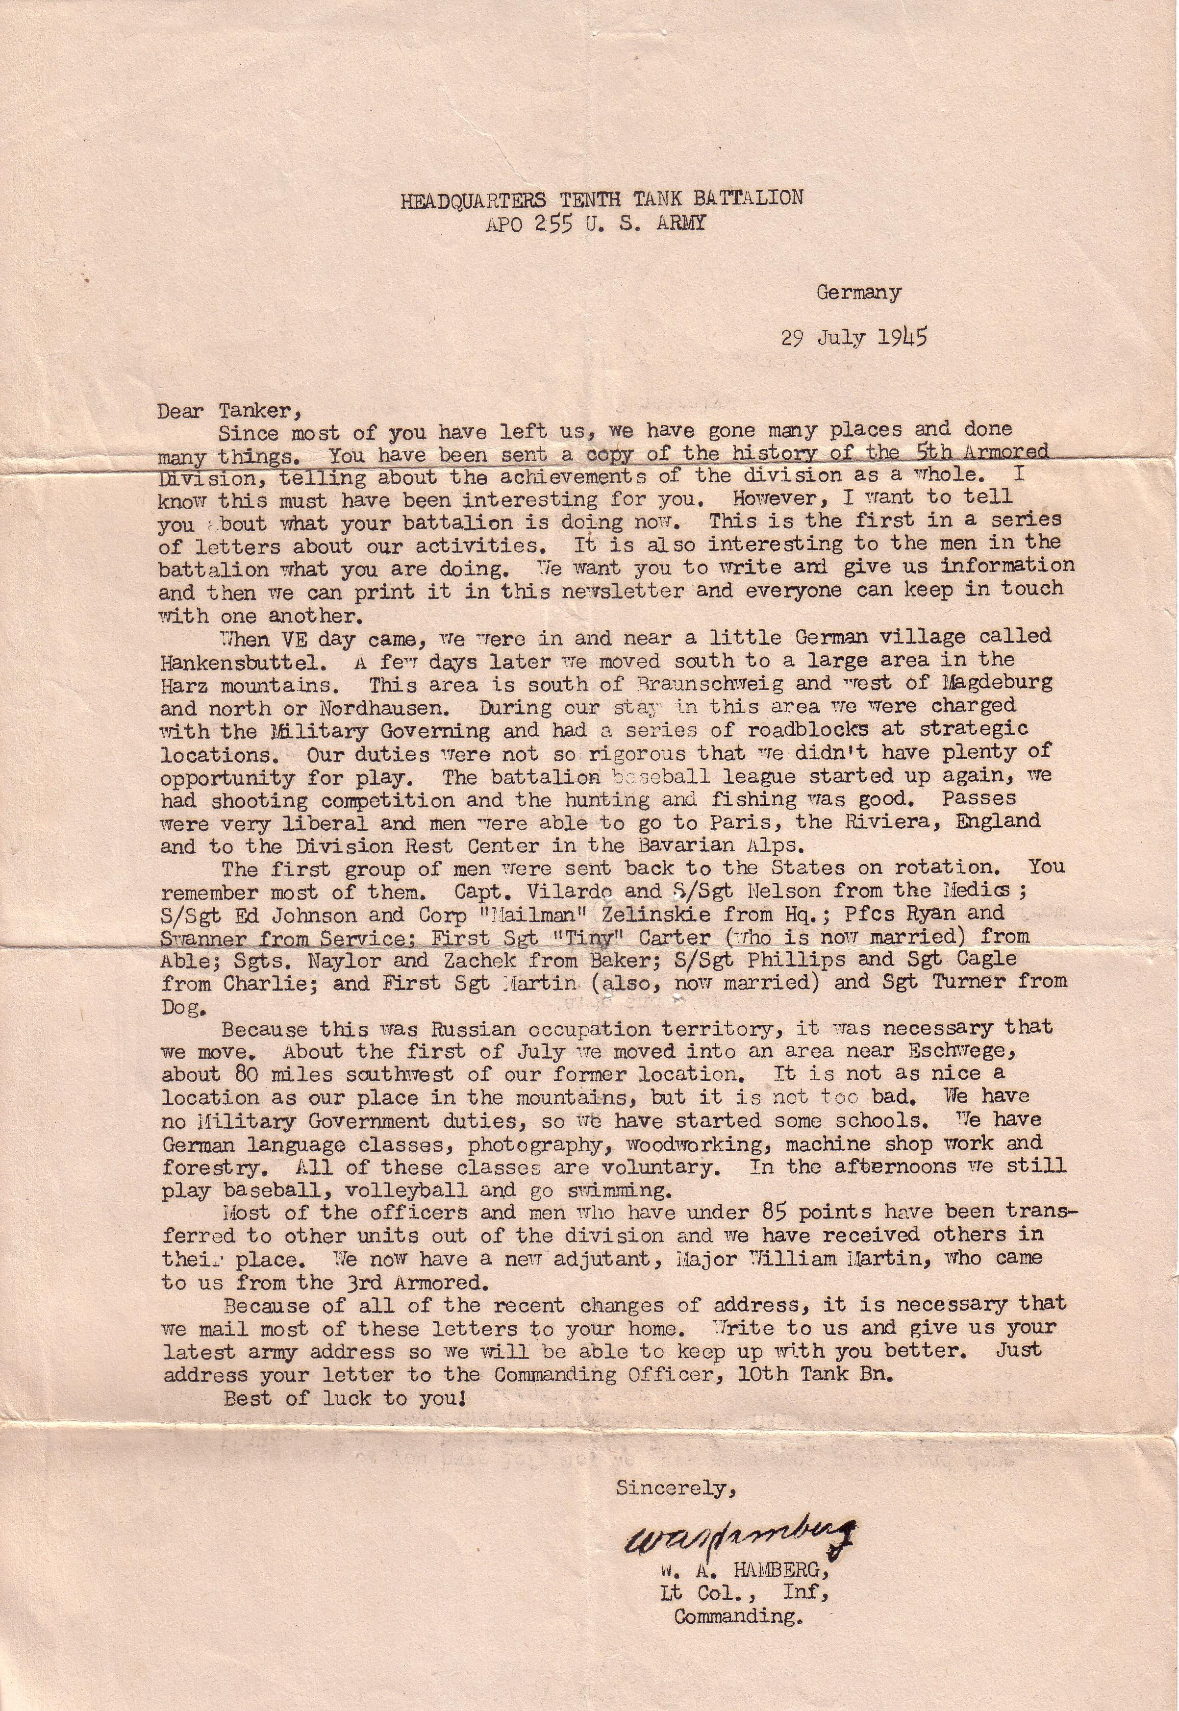
Letter courtesy of Patrick Lagger, a citizen of Switzerland

